What is BitBuckets

BitBucket is a cloud-based service that helps developers store and manage their code, as well as track and control the changes to their code. BitBucket provides a cloud-based Git repository hosting service.

**What Is Git?**

Git is a **specific open-source version control system** created by Linus Torvalds in 2005.

Specifically, Git is a **distributed version control system**, which means that the entire codebase and history is available on every developer’s computer, which allows for easy branching and merging.

Git is a version-control system for tracking changes in computer files and coordinating work on those files among multiple people.” So that means that the most basic and important function of Git is to allow teams to add (and merge) code at the same time to the same project

**What Is Github?**

Github cloud-based Git repository hosting service that helps developers store and manage their code, as well as track and control the changes to their code. Github provides a cloud-based Git repository hosting service.

| Parameters | Bitbucket | GitHub |
| --- | --- | --- |
| Developed by | Bitbucket was developed by Jesper Noehr. | GitHub was developed by Chris Wanstrath, Tom Preston-Werner, P. J. Hyett, and Scott Chacon. |
| Version Control Systems | It supports Mercurial and Git. | It supports only Git. |
| Public Repository | It allows users to have multiple free repository. | It allows users to have unlimited free repository. |
| Private Repository | Bitbucket allows users to have free private repository but with maximum of five collaborators. | GitHub allows users to have free private repository but with maximum of three collaborators. |
| Navigation | Bitbucket has no feature for navigation. | GitHub allows user to navigate usability. |
| Project Analysis | Bitbucket allows developers to visualize the analysis with charts | GitHub doesn’t have this feature yet but they can check the commit history. |
| Advantages | * Flexible with a variety of operating systems. * Authentication of social media support is created by Bitbucket. | * It helps us create an organized document for the project. * It is used for sharing the work in front of the public. |
| Disadvantages | * The maximum number of members can be 5 after that we need to pay for every additional member. * There is no stability when the process gets heavy and it results in slow down. | * There is a limited private repository. * It supports only Git version control. |
| Semantic Search | Supports Semantic Search features such as classes, and interfaces, etc thus saving a lot of time. | GitHub does not support Semantic Search features. |

## What is Jenkins and why we use it?

Jenkins is an open-source automation tool written in Java with plugins built for continuous integration. Jenkins is used to build and test your software projects continuously making it easier for developers to integrate changes to the project, and making it easier for users to obtain a fresh build. It also allows you to continuously deliver your software by integrating with a large number of testing and deployment technologies.

Jenkins integrates development life-cycle processes of all kinds, including build, document, test, package, stage, deploy, static analysis, and much more.

### **Advantages of Jenkins include:**

* It is an open-source tool with great community support.
* It is easy to install.
* It has 1000+ plugins to ease your work. If a plugin does not exist, you can code it and share it with the community.
* It is free of cost.
* It is built with Java and hence, it is portable to all the major platforms.

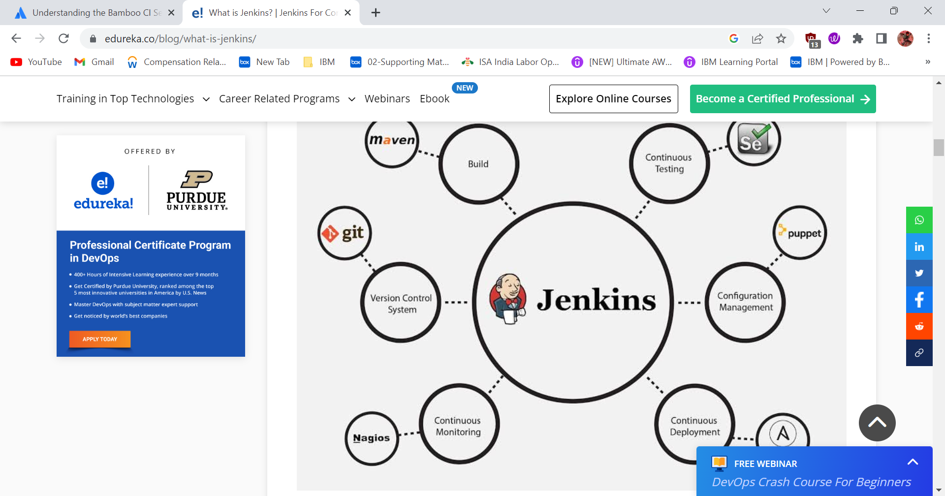

Jenkins is an open source [continuous integration](https://www.techtarget.com/searchsoftwarequality/definition/continuous-integration)/continuous delivery and deployment (CI/CD) automation software DevOps tool written in the [Java](https://www.theserverside.com/definition/Java) programming language. It is used to implement CI/CD workflows, called pipelines.

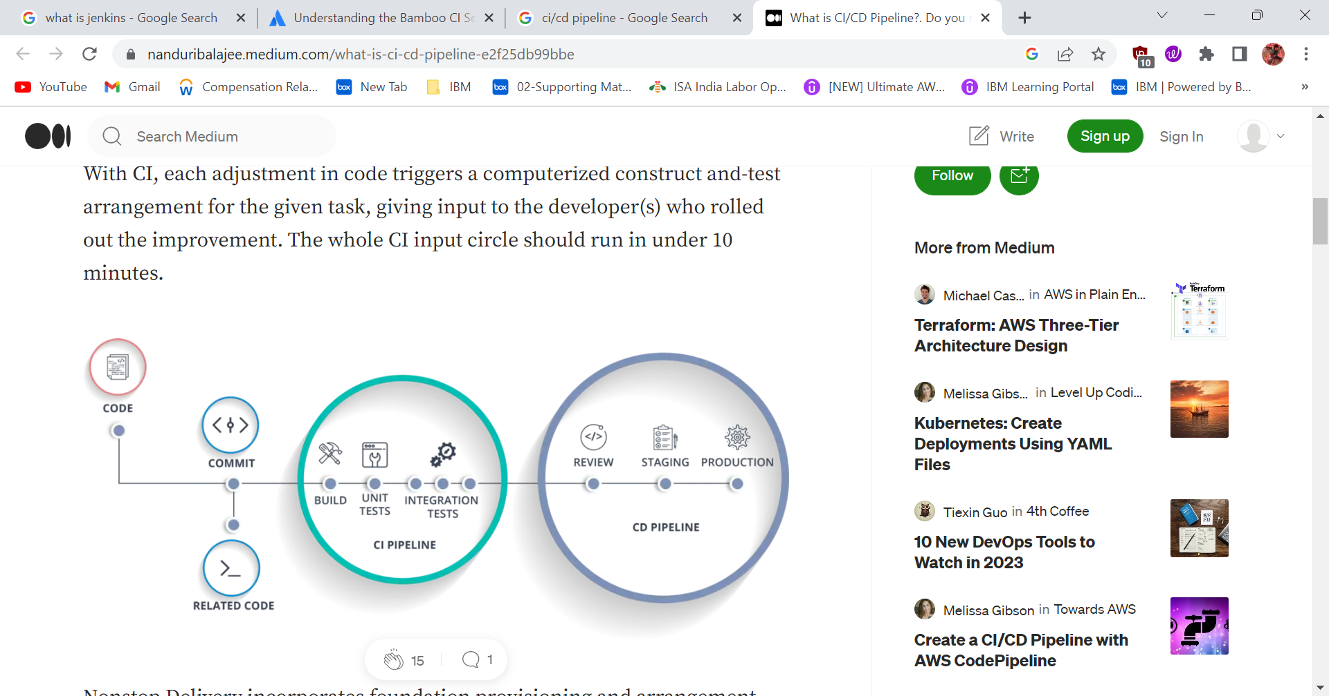

|  |  |  |
| --- | --- | --- |
| **Criteria** | **Jenkins** | **Bamboo** |
| **Ease of Setup** | Easy to setup | Compared to Jenkins, Bamboo takes a little more effort to setup |
| **Cost** | Jenkins is Open-Source and Free | Bamboo is paid like other Atlassian products and users have to subscribe to a plan for their team |
| **Plugins** | Jenkins uses 1000+ plugins. | Bamboo doesn’t use as many plugins as Jenkins use. Rather it has more built-in features |
| **User-friendliness** | Jenkins is not very user friendly | Bamboo is user friendly due to its GUI |
| **Docker** | No support for Docker | Has in-built Docker support |
| **Platforms** | Works on Mac, Windows, Ubuntu, and Redhat | Works on Windows, Linux, Solaris |
| **Support** | It has detailed documentation and community support | It is commercial software and provides support for licensed users |